How to Register for a Zoom workshop

Go to lsu.zoom.us and click on Login

Enter your LSU email

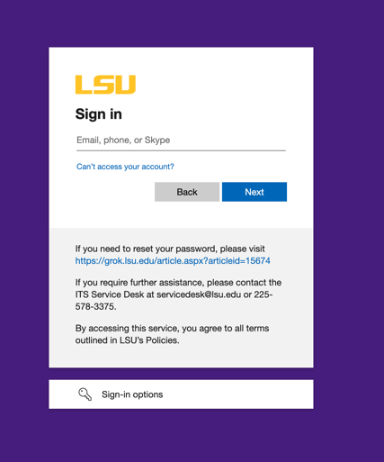

Enter your MyLSU password

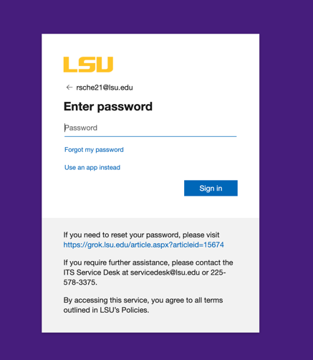

Once you sign in this way, go back and register on

https://lsu.edu/cas/mathstrategies.php

